# Confidence interval

## Two tailed test

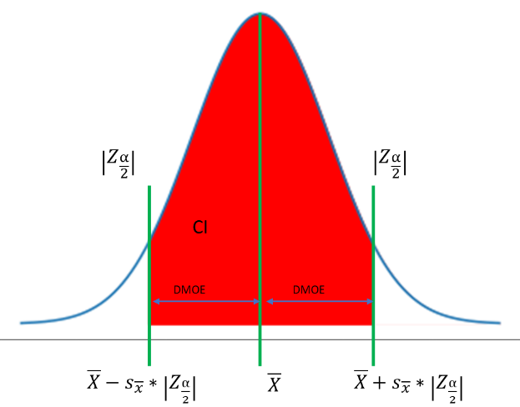

### Estimate population mean

Given:

1. Error (α)
2. Population std. dev. (σ)
3. Number of sample (n)
4. Sample mean (X_bar)

Calculate:

1. $\left|Z_{\frac{α}{2}}\right|$ = NORM.INV(α/2,0,1) for Z test and $\left|t_{\left(\frac{α}{2}, df\right)}\right|$ = T.INV(α/2, df) for t test df = n-1
2. Standard deviation of sample mean = σ/SQRT(n) = SX_bar and
3. Lower limit of population mean (LL)= X_bar - SX_bar*
4. Upper limit of population mean (UL)= X_bar + SX_bar*

### Estimate Population proportion:

Given:

1. Error (α)
2. Sample proportion (p) or can be derived by success criteria

Calculation:

1. Mean of sample proportion distribution p replace it with X_bar.
2. Std. dev. of sample proportion distribution = SQRT(p*(1 - p)/n) replace it with SX_bar
3. Lower limit of population mean (LL)= X_bar - SX_bar*
4. Upper limit of population mean (UL)= X_bar + SX_bar*

### Estimate minimum number of samples

Given:

1. Error (α)
2. Population std. dev. (σ)
3. Sample mean (X_bar)
4. DMOE

Calculate:

$$n≥{\left(\frac{σ*\left|Z_{\frac{α}{2}}\right|}{DMOE}\right)}^{2}$$

## Lower tailed test

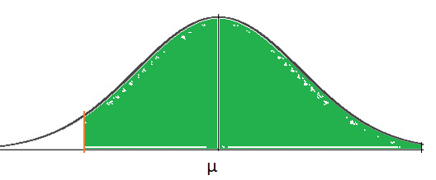

Lower limit of population mean (LL)= X_bar - SX_bar*

## Upper tailed test

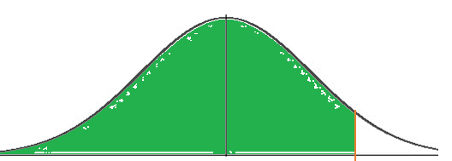

Upper limit of population mean (UL)= X_bar + SX_bar*

# Hypothesis testing

## Quadrants of operation

|  |  |  |
| --- | --- | --- |
|  | **H0** | **H1** |
|  | **H0 is true** | **H0 is false** |
| **Conclude H0 is true** | Good decision | β (Type 2 Error)  **Implication** |
| **Conclude H0 is false** | α (Type 1 Error)  **Implication:** | Good decision |

## One sided left tail

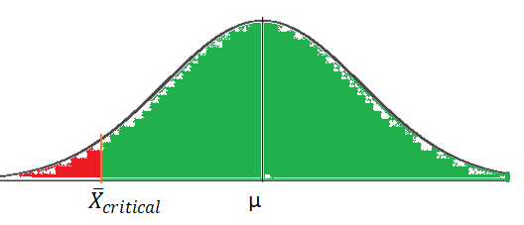

To reject null hypothesis sample mean should be < ${\overline{X}}_{critical}= μ- \left|Z_{α}\right|*\frac{σ}{\sqrt{n}}$…. (i)